REGISTRATION FORM
Eighth International Conference of the Balkan Association
of Roman Law and Roman Lеgal Tradition
« Societas pro iure romano »
"FEMINAE"

University of Rijeka – Faculty of Law,
Cres, October 5-7, 2023

Please complete the data in English and in the language in which you will participate in the conference and send by June 30, 2023 at ius.romanum2023@pravri.uniri.hr. Thank you!

First Name, Last Name
Aacademic position and degree
Home university
Postal address
E- mail address
 | In English | In the language in which you will participate in the conference.
Title of communication/article
Abstract
(not more than 100 words)
Keywords (not more than 10 words)

Signature:
(an electronic signature is possible)

We would kindly ask those of you who have not yet made your requests in the registration form for objective reasons to do so by the 20 May 2023 at the latest by sending a reservation to the address of Hotel Kimen: hotelkimen@hotelkimen.com, making a copy of the letter on the conference address as well, to avoid mismatches. We kindly ask you that the letter to the hotel has explicitly written "About the SIR conference October 5-7, 2023."

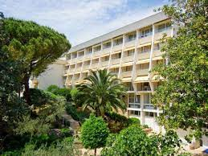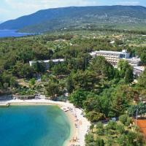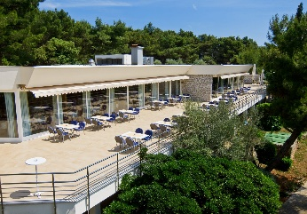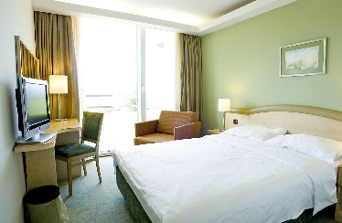

1. The price of half board per room is (per day):
- a double room with a view of the park is 70 Euro (Type A1)
- double room with sea view is 80 Euro (Type A2)
- a double room with a view of the park (one person) is 56 Euro (Type A3)
- a double room with a sea view (one person) is 66 Euro (Type A4)

2. The price of full board per room is (per day):
- a double room with a view of the park is 100 Euro (Type B1)
- a double room with a sea view is 110 Euro (Type B2)
- a double room with a view of the park (one person) is 71 Euro (Type B3)
- double room with sea view (one person) is 81 Euro. (Type B4)

The drinks with lunch and dinner are not included in all listed prices.
The prices are valid for the participants of the meeting and for their companions.

The official languages are English, Italian and French.

