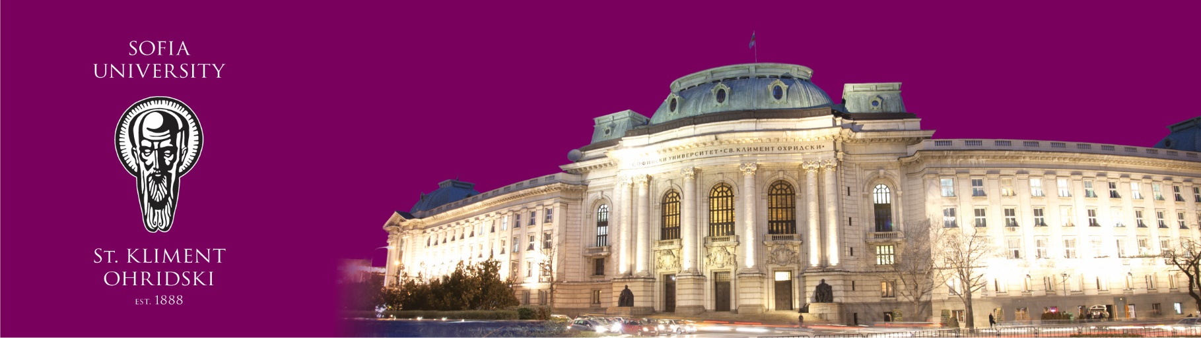
New International Constitutional Law and Administration Spring School
NICLAS
23-26 March 2020, Sofia, Bulgaria
Application Form

Name of the applicant
Institution
Academic status (BA, MA, PhD student, other) – please specify semester of study

Level of English language

Short description of the motivation for participation in NICLAS

